Decision Tree
Supervised

Classification Regression
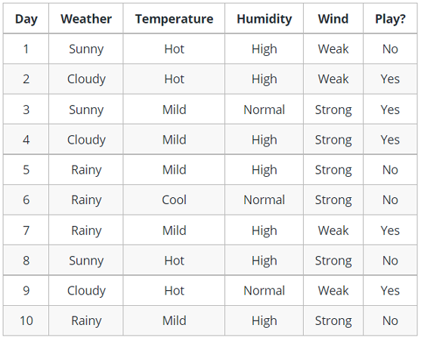

E(ALL) = -p₍₊₎logp_{(+) –} p₍₋₎logp₍₋₎

Entropy ALL = E(ALL)
E(ALL){+5,-5} = -5/10 log₂5/10 - 5/10 log5/10 = = 0.95
E(sunny )=0.97
E(cloud) = 0
E(RAINY) = 0.85

Information gain = entropy whole dataset – entropy of given attribute

IG(weather) =E(All) – 3/10(0.97) – 3/10(0)- 4/10(0.85)
IG of weather = 0.24
Ig temp =0.029
Ig humid = 0

We have to find IG of all the attribute
